

Architecture Design

Revision Number 1.0

Last Date of Revision 25/04/23

-Madhvendra Singh

Document Control

Date | Version | Description | Author
24/11/21 | 1.0 | Introduction, Architecture | Madhvendra
 |  | Deployment | Singh


Contents

Document Version Control
1. Introduction

1.1 What is Architecture Design Document ?

1.2 Scope
2. Architecture

2.1 Power BI Architecture

2.2 Components of Power BI Architecture
3. Deployment

3.1 Power BI Deployment

3.2 Publish datasets and reports from Power BI Desktop
1. Introduction

1.1 What is Architecture Design Document?

Every Software needs the architectural design to represents the design of software. IEEE defines architectural design as “the process of defining a collection of hardware and software components and their interfaces to establish the framework for the development of a computer system.” The software that is built for computer-based systems can exhibit one of these many architectures.

1.2 Scope

Architecture Design Document (ADD) is an architecture design process that follows a step-by-step refinement process. The process can be used for designing data structures, required software architecture, source code and ultimately, performance algorithms. Overall, the design principles

may be defined during requirement analysis and then refined during architectural design work.
2. Architecture

2.1 Power BI Architecture

Power BI is a business suite that includes several technologies that work together. To deliver outstanding business intelligence solutions.

Microsoft Power BI technology consists of a group of components such as:

- Power Query

- Power BI Desktop

- Power BI Mobile

- Power Pivot

- Power View

- Power Map

- Power Q&A

In simple terms a Power BI user takes data from various data sources such as files ,online services , Direct Query or gateway sources and then works on them using tools such as Power BI Desktop.
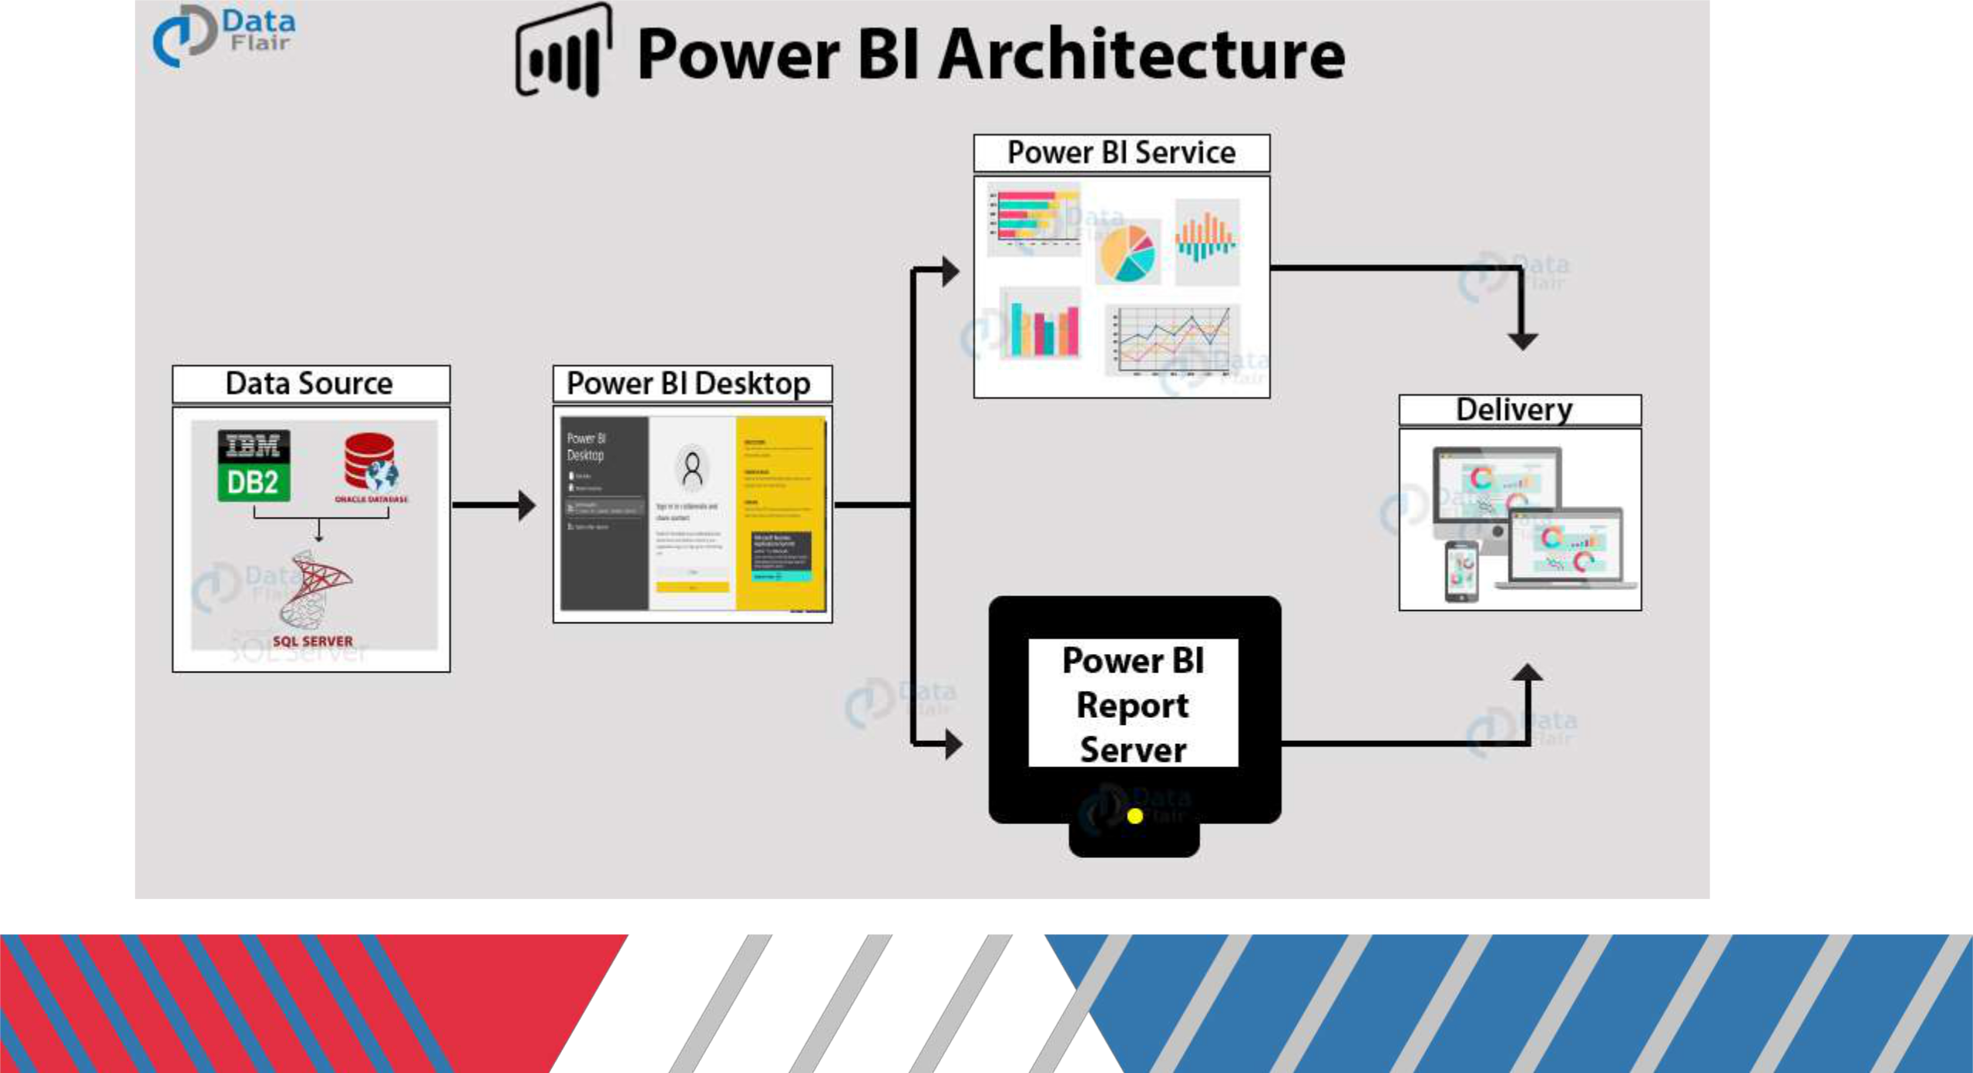
3. Deployment.
Architecture3.1PowerBIDeployment

The deployment process lets you clone content from one stage in the pipeline to another , typically from development to test and from test to production.

During deployment , Power BI copies the content from the current stage ,into the target one. The connections between the copied items are kept during the copy process. Power BI also applies the configured deployment rules to the updated content in the target stage.

3.2 Publish Datasets and reports from Power BI Desktop
When you publish a Power BI Desktop file to the Power BI service, you publish the data in the model to your Power BI workspace.

2. Architecture
Arts and literature

Provide examples of art and literature that are
significant to Jewish American Heritage Month.
Here are a few examples:

- The writings of David Mamet

- The music of Barbra Streisand

- The artwork of Annie Leibovitz



Conclusion

Provide a brief summary of your presentation.
Remind the audience what you covered in the previous slides.

